PROJECT DOCUMENTATION / BRAINSTORM & IDEA PRIORITIZATION TEMPLATE

Brainstorm & Idea Prioritization Template
Generate practical ideas, then focus the build on the highest-value automation
DATE  07 October 2026 | STUDENT NAME  Gangadevi.R | PROJECT  Incident Life Cycle Automation

Step 1 - Selected problem
How might we automate the incident lifecycle so that each incident is captured, prioritized, owned, tracked against SLA, escalated when necessary, and closed with a complete audit trail?

Step 2 - Idea generation & grouping
Theme | Ideas
Intake | Structured incident form; automatic incident ID; mandatory fields; source tagging
Triage | Category rules; priority rules; duplicate check; impact/urgency capture
Assignment | Rule-based routing; owner acknowledgement; reassignment
SLA | SLA timer; due-time indicator; breach detection; escalation notification
Resolution | Resolution notes; evidence/attachments; requester confirmation
Visibility | Role-based dashboard; status filters; open/overdue views; audit history

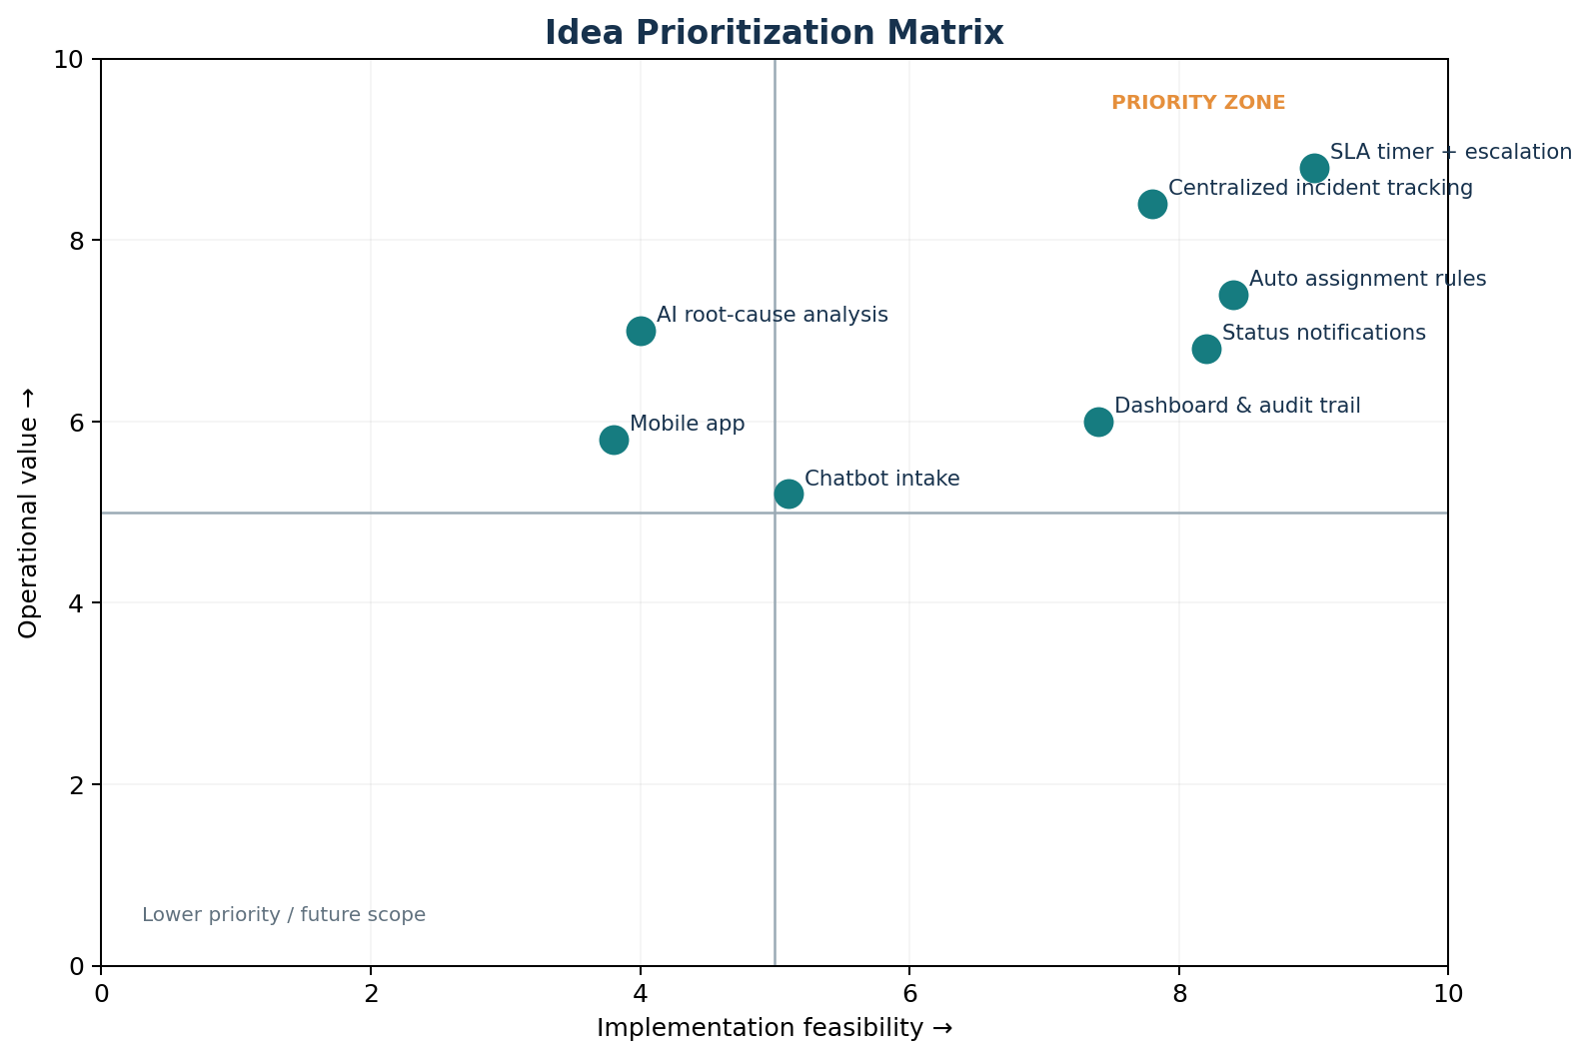

Step 3 - Prioritized build scope
- P1 - Core: incident intake, lifecycle status, priority, assignment, SLA timer, escalation, resolution and closure.
- P2 - Operational visibility: dashboards, filters, audit history and basic reporting.

